El Examen Final de Espanol 1
Unidad 3 | Unidad 4 | Unidad 5
Yo puedo…  □ …name food vocabulary  □ …conjugate –AR/-ER/-IR verbs  in the present tense  □ …tell what you like with gustar  □ …name family members  □ …use possessive adjectives  □ …tell people’s ages  □ …tell what you have with tener | Yo puedo…  □ …talk about clothes  □…conjugate stem-changing verbs  □ EIE  □ EI  □ OUE  □ …tell what you’re going to do  with ir + a  □ …recognize and use direct  objects  □ …talk about food and  restaurants  □ …discuss places in the city | Yo puedo…  □ …talk about the house  □ …conjugate verbs with irregular  yo forms  □ …differentiate ser v estar  □ …talk about chores  □ …use ordinal numbers  □ …talk about a party  □ …use affirmative tu commands

Crea tu final | Completa los papeles
Assignment: Create a sample final. In groups work together to create a final. You are responsible for creating 5 questions per objective above. You may use questions from previous quizzes, tests, homework, or notes, but you will only receive extra credit for the questions you come up with on your own.  On your final sheet, make sure you have all names and your team name on the sheet for full credit.  Due Date: 31 de Mayo  Assignment worth: 100 pts | Assignment: Complete this packet. This packet should completely prepare you to take the final Spanish I exam. Your packet must be complete, and since it will help you on the exam, you should work to make sure that everything is correct.  Due Date: 3 de Junio  Assignment worth: 100 pts
Unidad Preliminar
Yo puedo…differentiate subject pronouns
I | We
You
He  She  You (formal) | They (masc)  They (fem)  You all
Yo puedo…name parts of speech
Noun = | - Something that replaces a direct object
Verb = | - Replaces a noun
Adjective = | - What the action is done to
Subject pronoun = | - Action word
Possessive pronoun = | - A word that describes a noun
Direct object pronoun | - A person, place or thing
Direct object = | - Replaces the proper noun
Unidad 3
Yo puedo…name food vocabulary
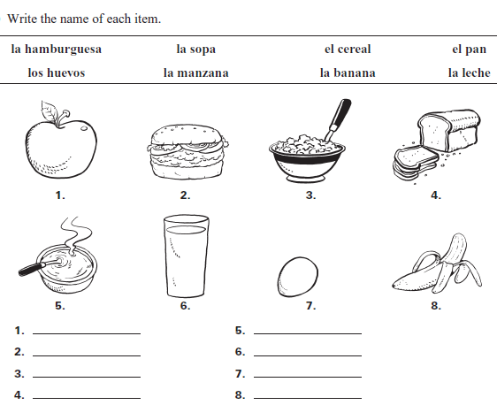

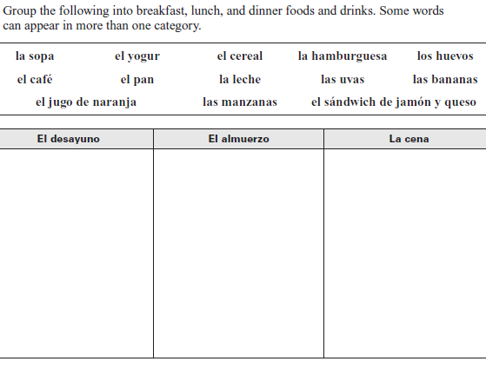

Yo puedo……conjugate –AR/-ER/-IR verbs in the present tense
 | -AR | -ER | -IR
Yo
Tu
El/Ella/
Usted
Nosotros
Ellos/Ellas
Ustedes
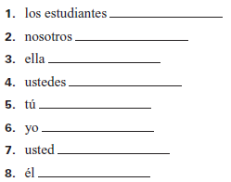
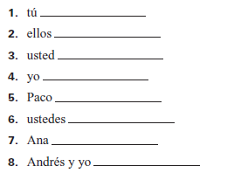
Instrucciones: Complete the chart with the correct endings for each verb type
Hablar Comer Escribir
- Yo________________________
- Maribel_____________________
- Nosotros____________________
- Andres______________________
- Ustedes_____________________
- Mi mama____________________
- Tú________________________
- Los maestros_________________
Complete the following sentences using the information given:
- Yo / practicar / un deporte ___________________________________________________________
- Guatavo / cantar / musica clasica ________________________________________________________
- Lucy y Shawn / aprender mucho / en la clase __________________________________________________
- Las niñas / montar en bicicleta ______________________________________________________________
- Tu / preguntar mucho ______________________________________________________________
- Sofia / beber mucho / jugo ______________________________________________________________
- Rafael y yo / leer / una revista ______________________________________________________________
- Mi madre / comer / mucha fruta ______________________________________________________________
- El autobús / partir / tarde ______________________________________________________________
- Todos los amigos / asistir / la fiesta ______________________________________________________________
- Gonzalo / insistir/ en ser el jefe ______________________________________________________________
- Tu / describir / las jugadas ______________________________________________________________
- Ellos / vender / la fruta en la cafetería ____________________________________________________________
- Yo / escribir en el pizarrón / en la clase __________________________________________________________
- Nosotros / comer un pizza / para desayuno _________________________________________________________

Yo puedo…tell what you like with gustar
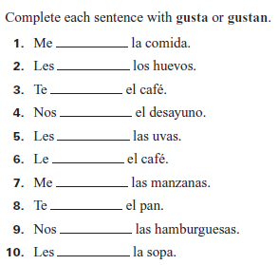
Thing that I like is singular, use _________
Ex. Me __________ la hamburguesa
Thing that is liked is plural, use __________
Ex. Me __________ las uvas.
A mi _____ gusta a nosotros _____ gusta
A ti ______ gusta
A el a ellos
A ella _____ gusta a ellas ____ gusta
A usted a ustedes

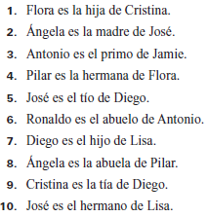
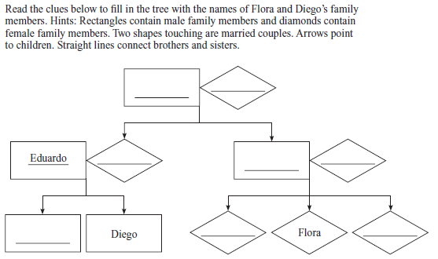
Yo puedo…name family members

Dime: Fill in the chart to tell who each of these people are
El padre | La madre | Los padres
El hermano | La Hermana | Los hermanos
El tio | La tia | Los tios
El abuelo | La abuela | Los abuelos
El primo | La prima | Los primos
El hijo | La hija | Los hijos

Yo puedo…use possessive adjectives
Singular Possessive Adjectives |  | Plural Possessive Adjectives
My  Your  His/hers | Our  Their | My  Your  His/Hers | Ours  Theirs

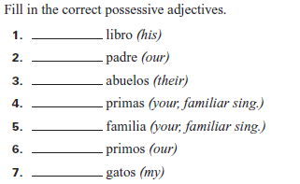
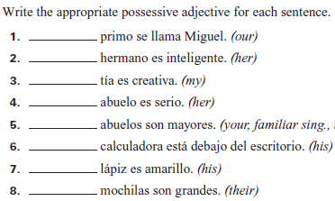
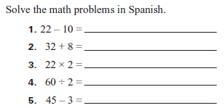
Yo puedo…tell people’s ages using tener
Yo | Nosotros
Tu
El  Ella  Usted | Ellos  Ellas  Ustedes

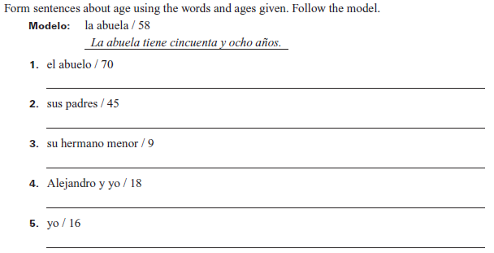

Unidad 4
Yo puedo…talk about clothes
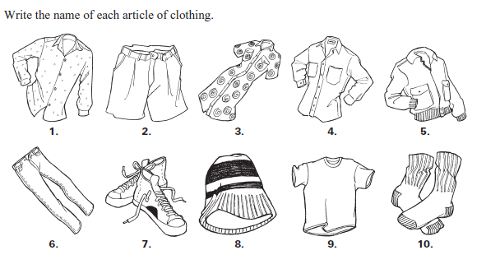
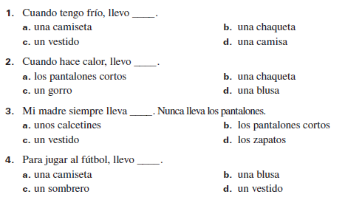
Yo puedo…conjugate stem-changing verbs (EIE, EI, OUE)
Categorize the stem-changing verbs below into the different stem-changing verb types. There is a chart on the next page. Complete the chart (and give definitions) for full credit.
Querer Poder Empezar Cerrar Encontrar
Servir Entender Almorzar Preferir Entender
Costar Pensar Volver

EIE | EI | OUE

 | Querer (EIE) | Pedir (EI) | Poder (OUE)
Yo
Tú
El
Ella
Usted
Nosotros
Ellos
Ellas
Ustedes

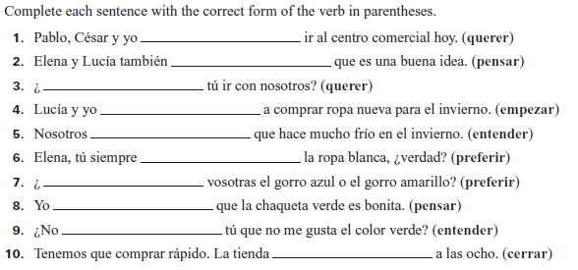
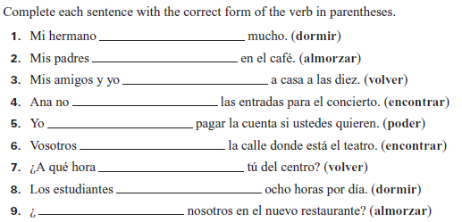

Yo | Nosotros
Tu
El  Ella  Usted | Ellos  Ellas  Ustedes
Yo puedo…tell what you’re going to do with ir + a
El + a = _____________
Ex. Yo / ir a / el restaurant
Yo voy al restaurant
- Tu / ir a / el parquet _________________________________________________________________________________________
- Nosotros / ir a / la pelicula _________________________________________________________________________________
- El / ir a / el concierto ________________________________________________________________________________________
- Yo / ir a / el cine _____________________________________________________________________________________________
- Juan y Paco / ir a / la iglesia _________________________________________________________________________________

Yo puedo…recognize and use direct objects
Me | Us
You
Him/It | Them(m)
Her/It | Them(f)
Direct object=the thing the action is being done to
Direct object pronoun=replaces the direct object

Circle the direct object in the following sentences
- Nosotros miramos la television 4. Tu entiendes nosotros
- Ellos tienen el libro 5. Ella compra la camisa
- Yo veo el perro 6. Juan prefiere los deportes
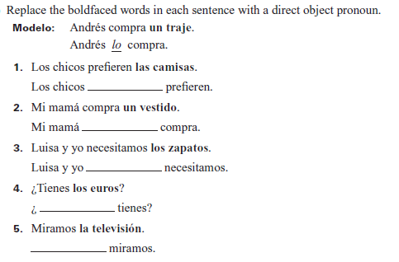
Steps:
- Find the direct object
- Cross it out
- See what would replace it (look at the chart)
- Move the direct object before the conjugated verb
Ex. Yo necesito el libro
Yo necesito el libro
Yo necesito (lo)
Yo lo necesito
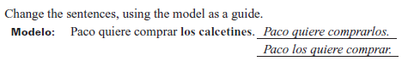
- Ella prefiere usar la calculadora _____________________________________________________________________________
- Ellos quieren comprar los jeans _____________________________________________________________________________
- Nosotros pensamos cerrar la tienda a las ocho _____________________________________________________________
Yo puedo…talk about food and restaurants & Yo puedo…discuss places in the city
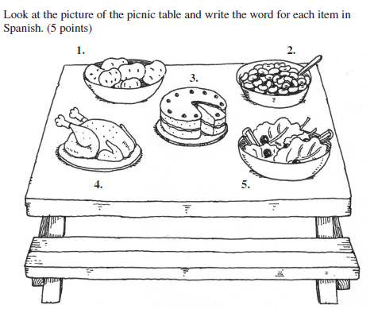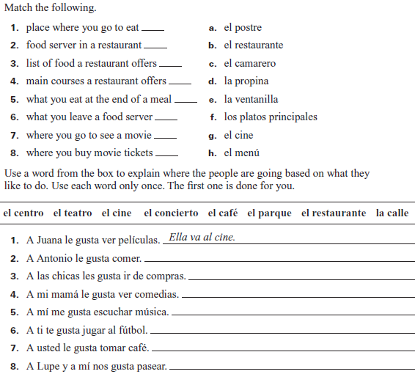
Unidad 5
Yo puedo…talk about the house
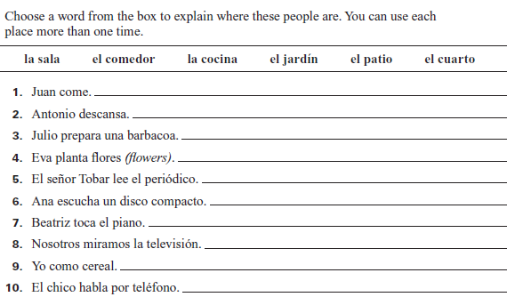
Yo puedo…differentiate ser v estar
D P
O L
C A
T C
O E
R

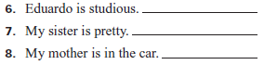
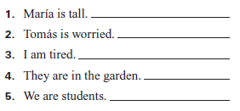
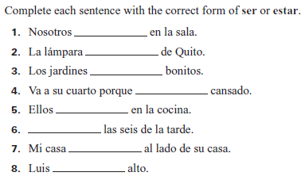

Yo puedo…conjugate verbs with irregular yo forms
 | Dar | Poner | Salir | Traer | Tener | Venir | Decir
Yo
Tu

You are giving a suprise party for your grandparents. Write the correct form of the verb in parentheses in the present tense.
Yo ______________________ (dar) una fiesta de sorpresa para mis abuelos. Mis hermanos _________________ (decir) que es aburrida pero pienso que es divertida. Nosotros _________________________ (poner) muchas decoraciones en la sala. Yo _________________ (poner) globos de muchos colores. Antes de la fiesta yo ____________________ (salir) con mi padre para comprar regalos. Yo ___________________ (traer) de los regalos. Cuando llegan mis abuelos nosotros ______________ (decir) “sorpresa” y empezamos la fiesta

Yo puedo…use ordinal numbers
1st | 2nd | 3rd | 4th | 5th
6th | 7th | 8th | 9th | 10th

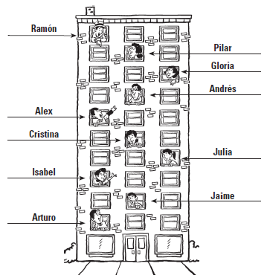
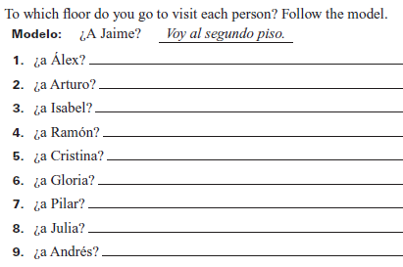

Yo puedo…talk about chores
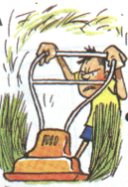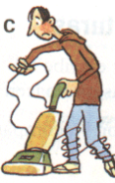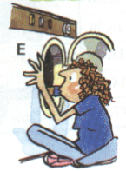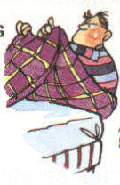
________________________ _________________________ _________________________ ___________________________
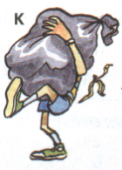 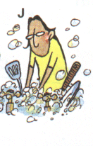 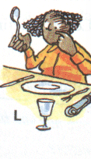________________________ _________________________ _________________________ ___________________________
Yo puedo…talk about a party & Yo puedo…use affirmative tu commands
