Spanish II Review Packet & Sample Final _____ / 300
You have until the day of the exam to turn in this packet as well as a created sample test (more on that in un minuto). You must answer all sections, and may check off the objectives as you review them. Utilize your notes, the website, and the textbook to answer the questions. Your final assignment will be to create a sample final exam for this course. It must be at least 50 questions and cover each of the objectives (you will tell which ones according to the example below).
Ejemplo:
Objetivo: Differentiate between preterito y imperfeto  Use the preterito with an AR verb | 5. Change the following sentence to the past tense, using either the preterito o imperfeto depending on the situation  Un dia yo camino a la fiesta.

Unidad 2  □ Yo puedo…talk about sports (  □ Yo puedo…use the preterite of  –AR, -ER, and –IR Verbs  □ Yo puedo…use demonstrative  adjectives and pronouns  □ Yo puedo…talk about daily routine  □ Yo puedo…use reflexive verbs | Unidad 3  □ Yo puedo…talk about clothes and  places to shop  □ Yo puedo…conjugate stem-  changing verbs  □ Yo puedo…conjugate verbs with  irregular yo  □ Yo puedo…talk about products in a  market  □ Yo puedo…express myself  courteously with a shop keeper  □ Yo puedo…conjugate irregular  verbs in the preterite  □ Yo puedo…conjugate stem-  changing verbs in the preterite | Unidad 4  □ Yo puedo…talk about fairy tales  and legends  □ Yo puedo…use the imperfeto tense  □ Yo puedo…differentiate the  imperfeto and preterito tenses

You may work together while completing the review packet and final exam. If you work in groups on the final project, turn in one sample final only (with everyone’s name on it). For every question I use of yours on the final exam you will get an extra credit point (up to 50pts—ie. the whole test), so make sure the questions are well-formed (question makes sense, only has one answer) and rigorous (difficult, comprehensive) to maximize your chances.

Due dates:
May 24 Sample Final due at the end of the hour (no late finals will be accepted)
June 3 Review Packet at the beginning of the hour (no late packets will be accepted)

***NOTE: THIS IS YOUR ONLY REVIEW PACKET. YOU WILL NOT GET ANOTHER. DO. NOT. LOSE. IT. Only the packet will be accepted, if you attempt to turn in the answers without the packet, you will still get a 0%. ***

Unidad 2
Yo puedo…talk about sports
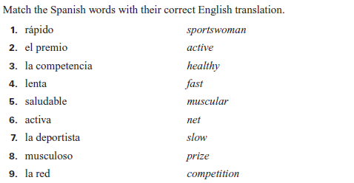
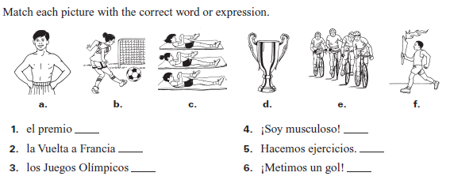
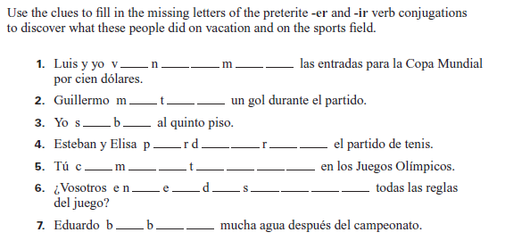

Yo puedo…conjugate –AR, -ER, and –IR verbs in the preterito
Fill in the chart below with the correct endings. Use this chart to help you answer the questions below
 | -AR | -ER/-IR
Yo
Tú
Él
Ella
Usted
Nosotros
Ellos
Ellas
Ustedes
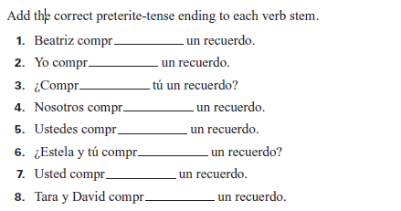

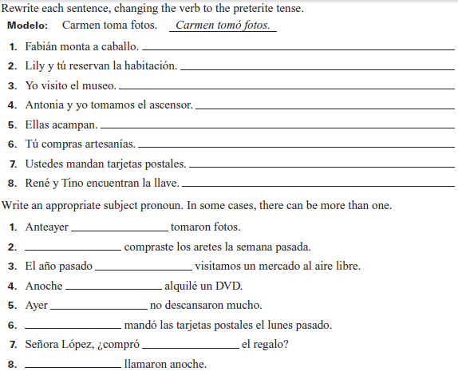

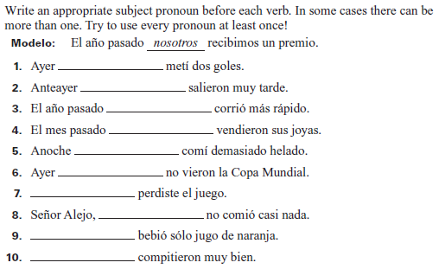

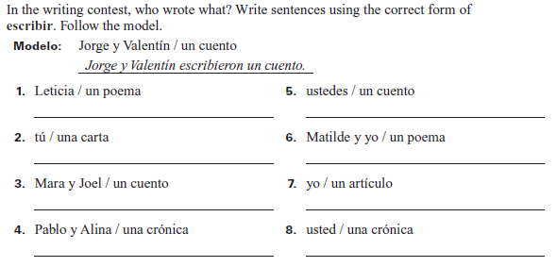
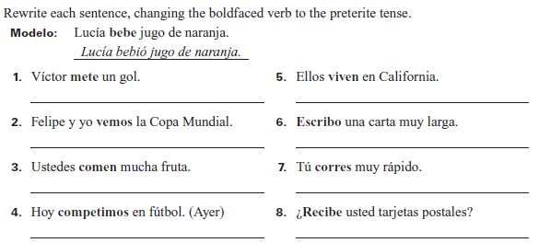

Yo puedo…use demonstrative adjectives and pronouns
Fill out the following chart of the demonstrative adjectives and use this to answer the questions below.
 | Close |  | Not too Far |  | Far away
 | m. | f. | m. | f. | m. | f.
Singular
 | this | this | that | that | that (far) | that (far)
Plural
 | these | these | those | those | those (far) | those (far)
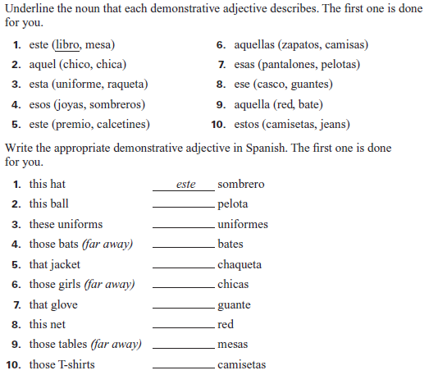
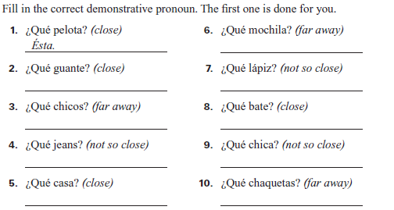

Yo puedo…talk about daily routine
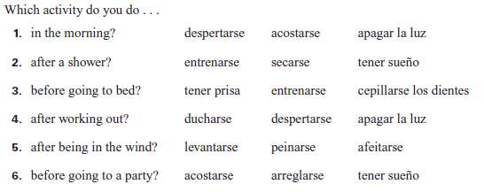

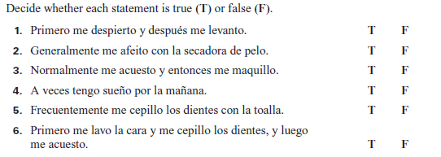

Yo puedo…use reflexive verbs to talk about daily routine
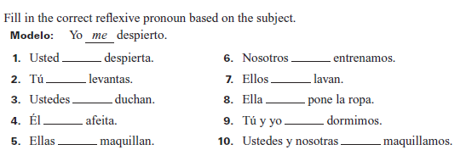

Manuel is completing a survey on daily habits for her health class. Complete her questions and responses using the present tense of the verbs in parentheses.
Entrevista: Hola Manuel. ¿A qué hora _________________ (acostarse)?
Manuel: Pues, temprano porque mis hermanos y yo _________________ (despertarse) a las seis de la manana.
Mis padres ______________ (levantarse) un poco mas tarde.
Yo siempre ______________ (dormirse) antes de las diez de la noche.
Entrevista: ¿Y tú, Julia? ¿Cuándo ____________ (arreglarse) tú?
Julia: Yo ____________ (despertarse) a las siete, pero normalmente _____________ (levantarse) a las ocho.
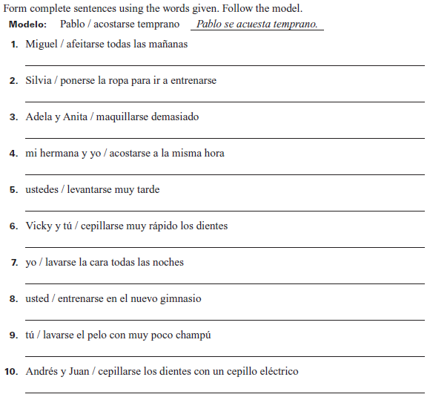
Unidad 3
Yo puedo…talk about clothes and places to shop

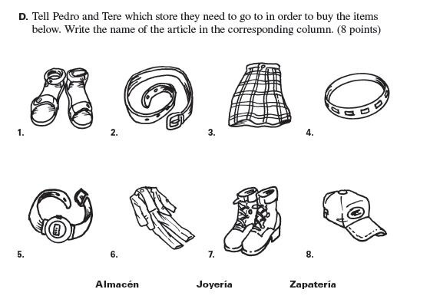
- _______________________
_______________________
- _______________________
_______________________
- _______________________
_______________________
- _______________________
_______________________
- _______________________
_______________________
- _______________________
_______________________
- _______________________
_______________________
- _______________________
_______________________

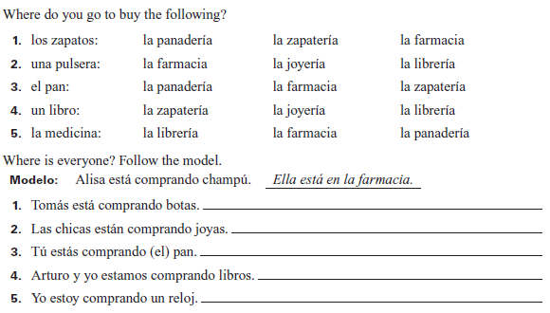

Yo puedo…express myself courteously with a shopkeeper
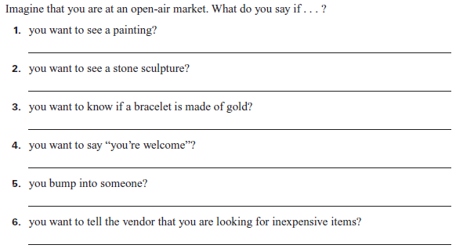
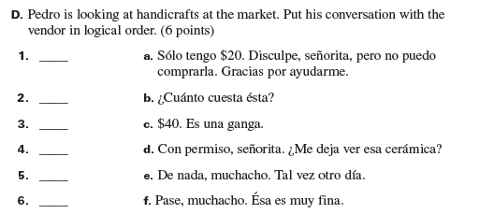

Yo puedo…conjugate verbs with irregular yo forms
-GO but not stem-changing
 | Hacer (to do/make) | Poner (to put) | Salir (to leave) | Traer (to bring)
Yo
Tú

-GO and stem-changing
 | Tener (to have) | Venir (to come) | Decir (to say)
Yo
Tú

Los Irregulares Totales
 | Conocer (to know-person) | Dar (to give) | Saber (to know-fact) | Ver (to see)
Yo
Tú

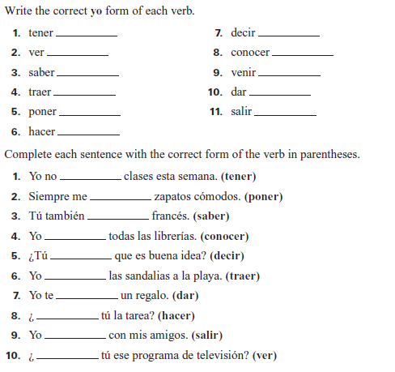

Yo puedo…conjugate irregular verbs in the preterite

Yo | Nosotros
Tú
Él  Ella  Ud | Ellos  Ellas  Ustedes
Estar ___________
Poder ___________
Poner ___________
Tener ___________
Saber ___________

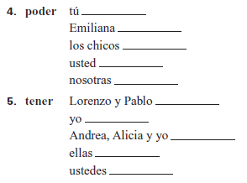
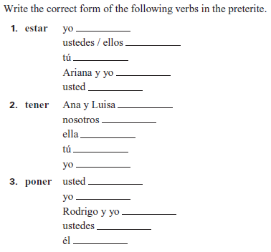

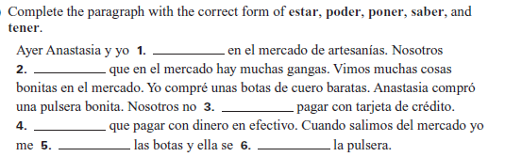
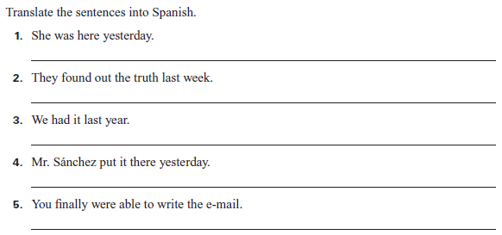

Yo puedo…conjugate stem-changing verbs in the preterite
 | EI |  |  |  |  |  | OU
 | Pedir  (to order) | Seguir  (to follow) | Preferir  (to prefer) | Vestirse  (to dress) | Servir  (to serve) | Competir  (to compete) | Dormir  (to sleep)
Yo
Tú
Él
Nosotros
Ellos

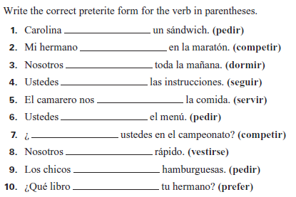
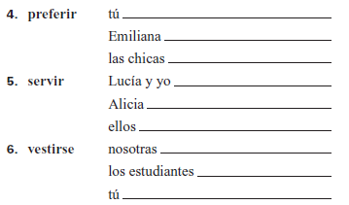
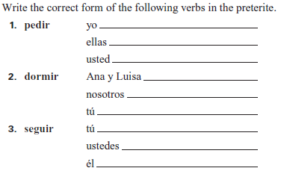

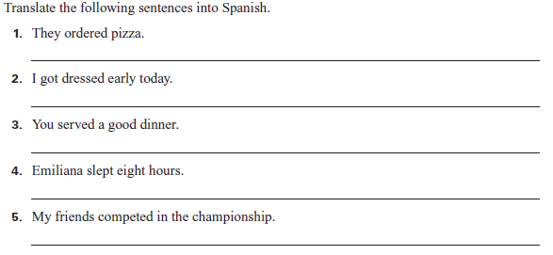

Unidad 4
Yo puedo…talk about legends and fairy tales
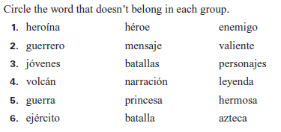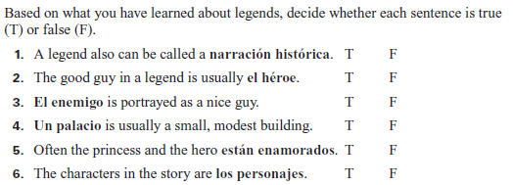
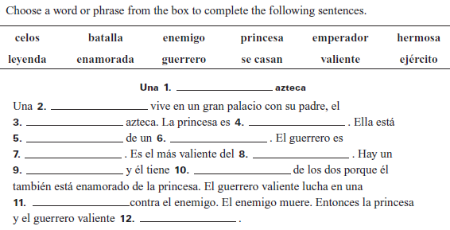
Yo puedo…conjugate verbs in the imperfect tense
 | -AR | -ER/-IR
Yo
Tú
Él
Nosotros
Ellos
IR | SER | VER

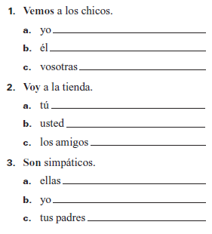
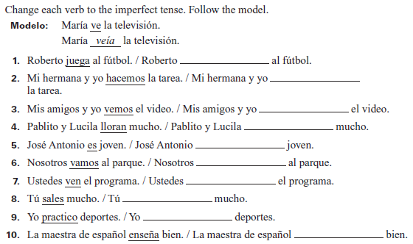
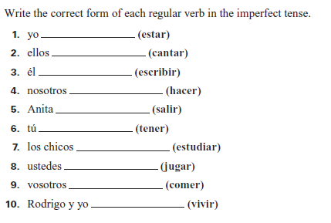

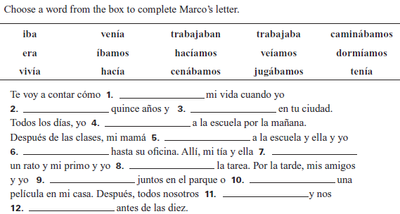

Yo puedo…differentiate between preterito y imperfeto
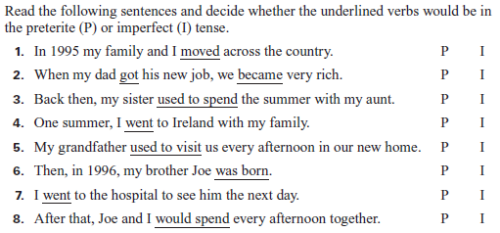
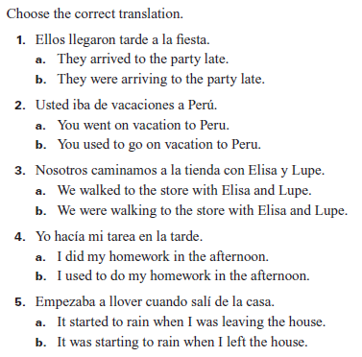
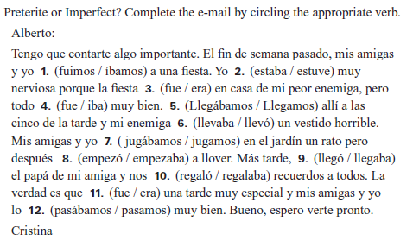
Vocabulario
Unidad 2  Talk about Sports  el campeonato championship  el ciclismo bicycle racing  la competencia competition  competir (i) to compete  estar empatado to be tied  jugar (ue) en equipo to play on a team  meter un gol to score a goal  el premio prize; award  la Copa Mundial The World Cup  los Juegos Olímpicos The Olympic Games  la pista track  la red net  el uniforme uniform  Talk about Your Daily Routine  acostarse (ue) to go to bed  afeitarse to shave oneself  apagar la luz to turn off the light  arreglarse to get ready  bañarse to take a bath  cepillarse los dientes to brush one’s teeth  despertarse (ie) to wake up  dormirse (ue) to fall asleep  ducharse to take a shower  encender (ie) la luz to turn on the light  entrenarse to train  lavarse to wash oneself  levantarse to get up  maquillarse to put on makeup  peinarse to comb one’s hair  ponerse la ropa to put on clothes  la rutina routine  secarse to dry oneself  tener prisa to be in a hurry  tener sueño to be sleepy  Clarify Sequence of Events  primero first  entonces then; so  luego later; then  más tarde later on  por fin finally  How often you do things  a veces sometimes  frecuentemente frequently  generalmente in general; generally  normalmente usually; normally | Unidad 3  Clothing and Accessories  el abrigo coat  las botas boots  el chaleco vest  el cinturón belt  la falda skirt  la gorra cap  la pulsera bracelet  el reloj watch  las sandalias sandals  el suéter sweater  el traje suit  Clothing Fit and Fashion  de cuadros plaid  de rayas striped  estar de moda to be in style  el número shoe size  la talla clothing size  vestirse (i) to get dressed  ¿Cómo me queda(n)? How does it (do they) fit me?  quedar… to fit . . .  bien well  mal badly  flojo(a) loose  apretado(a) tight  Where You Shop  el almacén department store  la farmacia pharmacy  Internet Internet  la joyería jewelry store  la librería bookstore  la panadería bakery  la zapatería shoe store  Items in the market  los artículos goods  barato(a) inexpensive  la escultura sculpture  fino(a) fine  una ganga a bargain  la pintura painting  el retrato portrait  único(a) unique  (estar) hecho(a) a mano (to be) handmade  ser de… to be made of . . .  cerámica ceramic  cuero leather  madera wood  metal metal  oro gold  piedra stone  plata silver  Expressions of Courtesy  Con mucho gusto. With pleasure.  Con permiso. Excuse me.  De nada. You’re welcome.  Disculpe. Excuse me.; I’m sorry.  No hay de qué. Don’t mention it.  Pase. Go ahead.  Perdóneme. Forgive me.  ¿Me deja ver…? May I see . . . ? | Unidad 4  Characters  el (la) dios(a) god/goddess  el ejército army  el emperador emperor  el (la) enemigo(a) enemy  el (la) guerrero(a) warrior  el héroe hero  la heroína heroine  el (la) joven young man/woman  la princesa princess  Events  la batalla battle  la guerra war  casarse to get married  contar (ue) to tell (a story)  llevar to take; to carry  llorar to cry  morir (ue) to die  pelear to fight  regresar to return  transformar to transform  Descriptions  azteca Aztec  estar enamorado(a) (de) to be in love (with)  hermoso(a) handsome; pretty  heroico(a) heroic  histórico(a) historic; historical  querido(a) beloved  los celos jealousy  tener celos to be jealous  valiente brave  la montaña mountain  el palacio palace  el volcán volcano  Parts of a legend  la leyenda legend  el mensaje lesson; message  la narración narration  el personaje character  Narrate Past Events  Había una vez... Once upon a time there was/were . . .  Hace muchos siglos... Many centuries ago .  sobre about
LEER
